**Experiment No.10**

**Aim:**  Write a function which takes a tuple as a parameter and returns a new tuple as the output, where every other element of the input tuple is copied, starting from the first one.

**Program A:**

def odd_indices(tup):  
 Odd_Tup = ()  
 for i in range(len(tup)):  
 if i % 2 != 1:  
 Odd_Tup += (tup[i],)  
 return Odd_Tup  
myTup = (991,882,773,554,475,426)  
print(odd_indices(myTup))

**Output:**

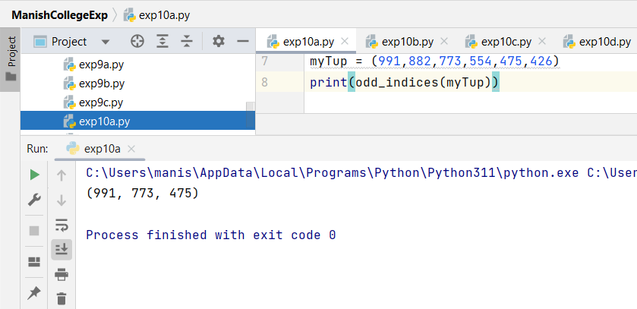

**Program B:**

def even_indices(tup):  
 even_Tup = ()  
 for i in range(len(tup)):  
 if i % 2 != 0:  
 even_Tup += (tup[i],)  
 return even_Tup  
myTup = (991,882,773,554,475,426)  
print(even_indices(myTup))

**Output:**

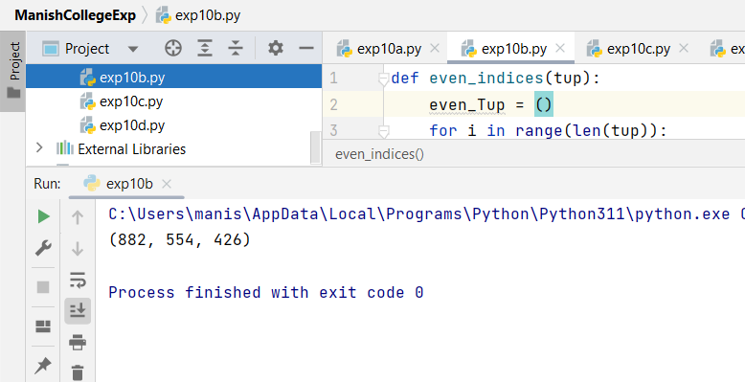

**Program C:** **Exercise:**

def indices(tup):  
 even_Tup = ()  
 for i in range(len(tup)):  
 if i % 2 == 0:  
 even_Tup += (tup[i],)  
 return even_Tup  
myTup = ('Hello','Are','You','Loving','Python?')  
print(indices(myTup))

**Output:**

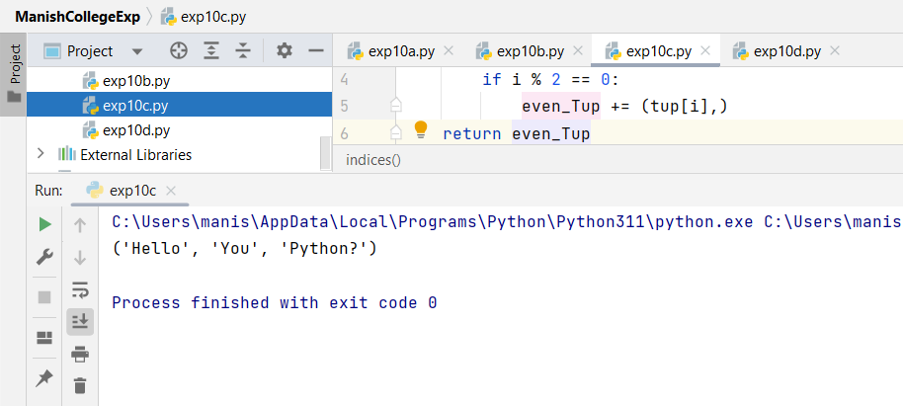

**Program D:** **Accessing Values in Tuples using Splice Operation:**

def slice_element(tup):  
  
 return tup[::3]  
input_tuple = (28,9,30,6,2,7,24,8,10,27,3,16,289)  
output_tuple = slice_element(input_tuple)  
print(output_tuple)

**Output:**

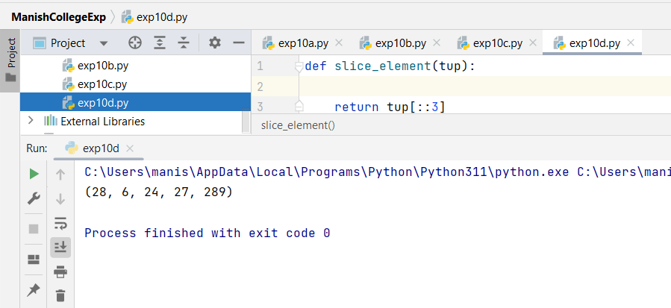

**Program E: Concatenating Tuples:**

tuple1 = (28, 11, 2)  
tuple2 = ('Manish', 'Aaryan', 'Pranay')  
  
tuple3 = tuple1 + tuple2  
  
print(tuple3)

**Output:**

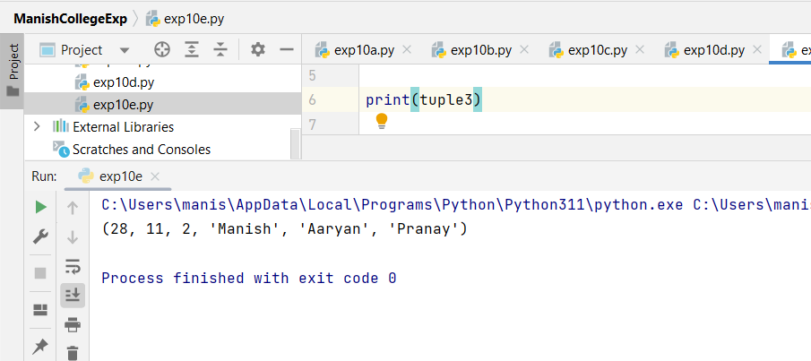

|  |  |  |  |
| --- | --- | --- | --- |
| **Practical Performance**  **(4)** | **Writeup & Oral**  **(4)** | **Attendance**  **(2)** | **Total**  **(10)** |
|  |  |  |  |